Lab 7
Name Shahab Ali
Sap id 54279
Firstly install winget install --id GitHub.cli
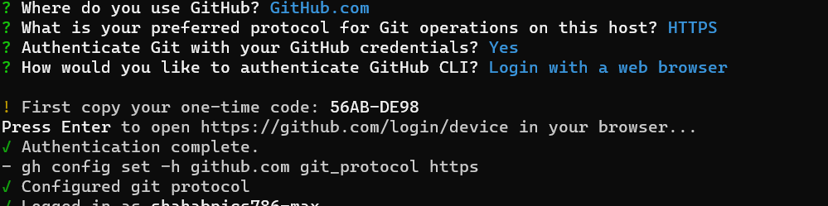
Then auth login and successfully installed.
Now run gh repo view cli/cli –web to check github cli web
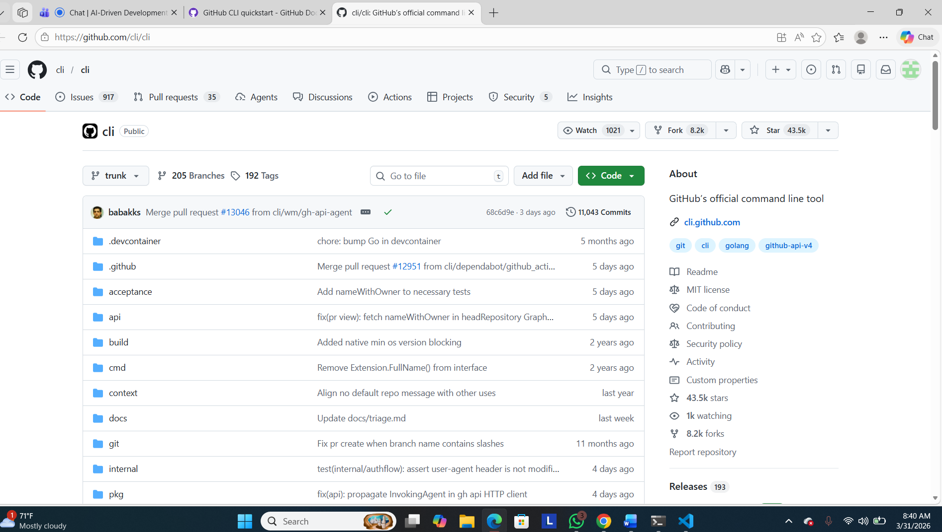
Check Status
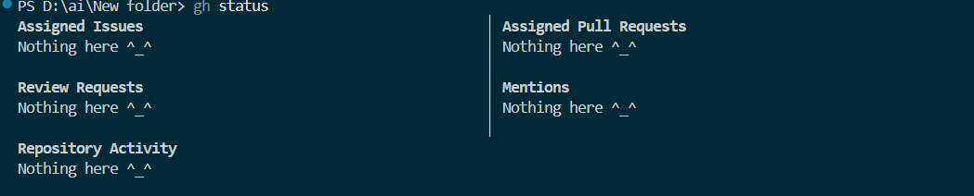
Now Viewing the repository
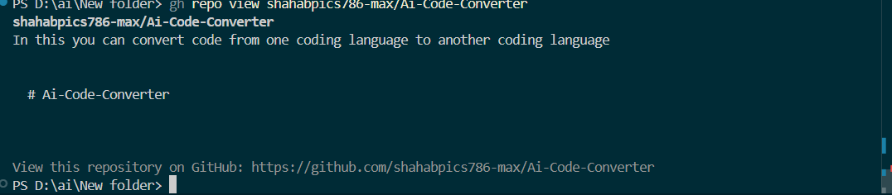
Now try to view repository through default browser
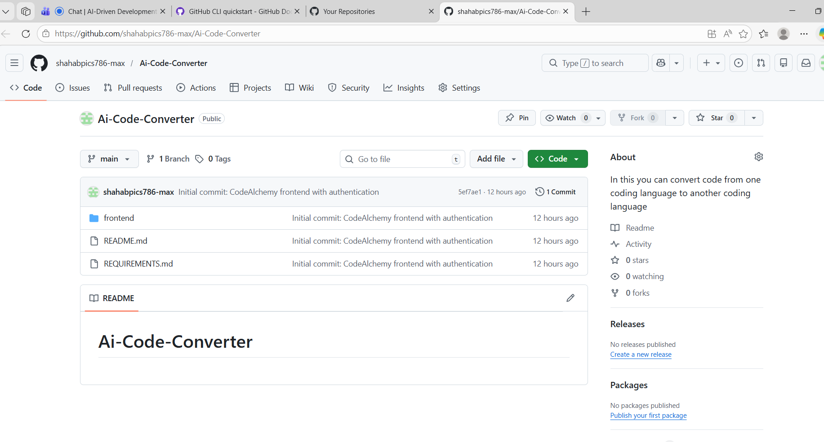
Now cloning the repo
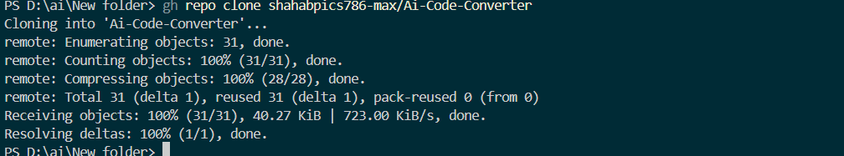
Check issue of existing repo
I work with already existing repo so there is no pr
Gh config list
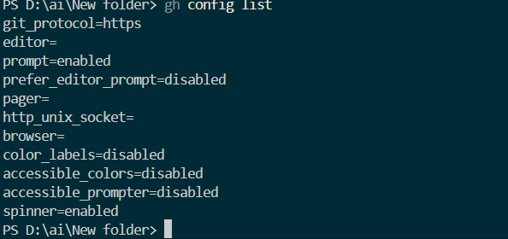
Gh alias for multiple commends
